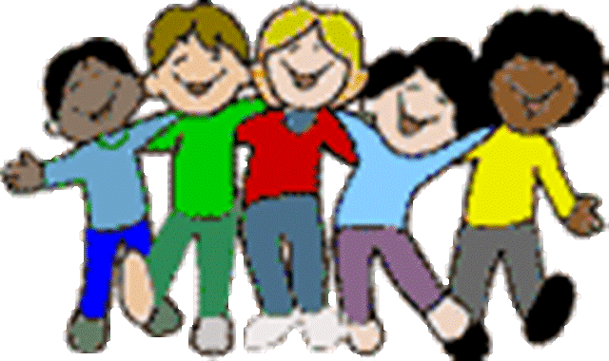
YEAR 1 LEARNING AT HOME GRID
Tasks to be completed over the FORTNIGHT: Tuesday 10th March - Friday 20th March
Reading  The home reader sheet is to be signed every night and sent back the next day to borrow a new reader. We ask that your child reads for 10 minutes at home - this can be achieved by your child reading independently, reading the book together or having a family member read the book to your child. It is perfectly fine to borrow the same book for a number of days if your child is not ready to move onto another text.  After you finish reading, discuss what part of the story you enjoyed, explain why you liked this part. Discuss where your favourite part of the story happened; at the beginning, in the middle or at the end of the story.  Draw this in your book.  Parent signature:  Date: | Maths  Over the next couple of weeks in Maths, we will be learning about time. With your family, think about the days of the week and talk about what you do each day during the week. Make a table in your book showing what your family does on those days. You can draw or write your activities.  For example:  Monday Tuesday Wednesday Thursday Friday Saturday Sunday  Parent signature:  Date:
Religion  In Religion we are learning about our Catholic Identity. As a family, write a prayer to show how God is present in your home. What is your family grateful to God for? How does your family thank God?  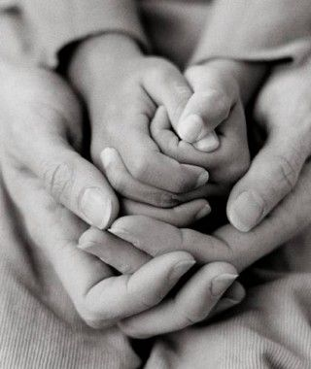  Parent signature:  Date: | Inquiry  In Inquiry, we are learning about ourselves - in particular our physical, social and emotional wellbeing. Explore the following websites that focus on children’s meditation and yoga to assist with emotional wellbeing.  Meditation: https://www.cosmickids.com/new-series-peace-guided-relaxations-kids/  Yoga:  https://www.cosmickids.com/category/watch/  Parent signature:  Date:
The tasks in bold print are the ESSENTIALS for the fortnight. CHOICES are strongly encouraged and all tasks should be signed off by a parent.
Please send a box (or two!) of tissues to school with your child for our class to share.
In Literacy, we are learning about Recounts. In Maths, we will be learning about time. In Inquiry, we are learning about our wellbeing and how to keep ourselves healthy. In Religion, we are learning about our Catholic Identity.

