Grade 5 Home Learning Grid
The following tasks are to be completed over the next two weeks in your home learning book. Due: Friday the 21st of February.
Please remember to see your classroom teacher before the due date if you would like extra support with your home learning tasks. Think about how you are going to organise your week of home learning so you are able to complete the tasks required before the due date. Shaded boxes are non-negotiables.
Reading/Diary | Writing | Spelling
Read your current reading book for at least 30 minutes every night.  Record your reading in your diary every night with your parent’s signature. This is a record of reading that will be used for the Semester reports.  Show your family the diary you will use as a reading log in grade 5. Discuss the requirements of recording in your reading each night and the responsibility you have to ensure that it is completed.  Parent signature:  Date: | Star of the Week  Continue and complete your Star of the week. You will be given time in class to start your star of the week writing, but this must be finished and returned to school by Friday each week.  Remember to write why this person has been chosen and the great things you have noticed about them. Use examples to support your comments.  Week 3: Be Responsible in Learning Spaces  Week 4: Be Safe in Learning Spaces  Parent signature:  Date: | Synonyms  Synonyms are words with the same or similar meaning. Brainstorm synonyms for the following words.  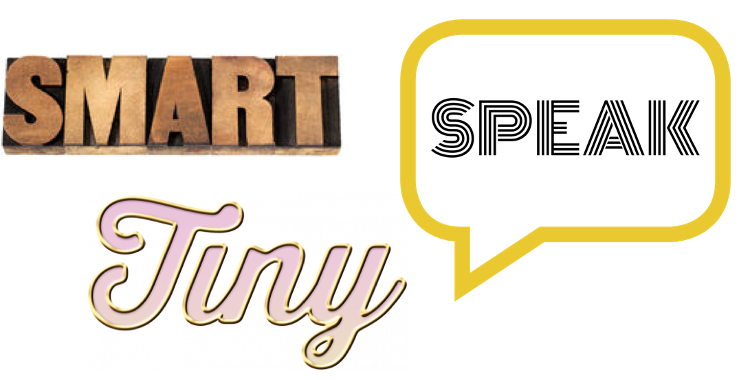  Parent signature:  Date:
Inquiry/Cyber Safety | Learning Conversations | Community and Events
As we begin our iPad program in Grade 5, it is important for all students to become safe and responsible digital citizens. This is why the school has organised school AND home user agreements for the program. Take some time to sit down and discuss with your family the user agreements and form some guidelines about the use of your iPad as a learning tool.  The students will begin taking their iPads home once they have shown they can take care of their iPads responsibly at school and be safe online users.  Parent signature:  Date: | To prepare for learning conversations with your teacher, brainstorm some ideas about what you would like to share with your teacher. You may like to list goals you wish to achieve this year.  Parent signature:  Date: | Reminders:  Please bring two tissue boxes into school for your learning space.  Please continue to return your iPad User Agreements to your classroom teacher.  Events:  Tuesday 11th February - Foot Steps Incursion  Parent signature:  Date:
Over the next fortnight, we will be focusing on: Narrative Texts (Writing), Letters and Active Readers (Reading), Place Value (Maths), Wellbeing of the Learner (Inquiry), Who is God? (RE)

5T | Sport: Monday | 5H | Sport: Thursday | 5M | Sport: Thursday

