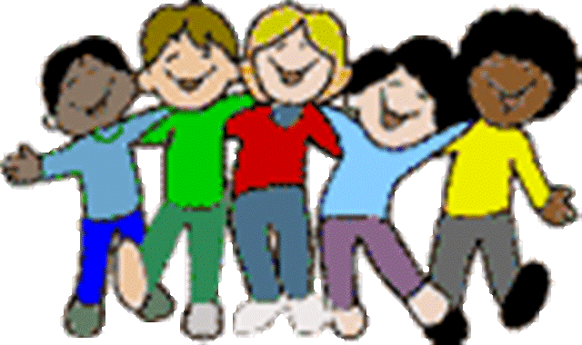
GRADE 3 - LEARNING AT HOME GRID
Tasks to be completed over the FORTNIGHT: Monday 10th February – Friday 21st February
Writing  We are in the process of setting up our ‘Writer’s Notebook’. Good writers find inspiration everywhere - from photos, special mementoes, or even things found on our daily travels. Collect your items in a small bag and we will use them as ideas for our writing.  Parent signature:  Date: | Reading  Read a book from home each night for 25 minutes. Record the title, date and your parent’s signature in your Home Learning book.  Parent signature:  Date: | Maths  We have begun our unit on Place Value. Pick a number in the thousands and represent it in a variety of ways - as a number, as a picture and as a sentence. Where can you find that number in a real life situation? Challenge yourself with a number in the tens of thousands!  Share the number with your family and ask them if they know any more ways to show the number.  Parent signature:  Date:
Religion  We have been learning about ‘Our Catholic Identity’ at St Lawrence Primary School. Create a prayer in your home learning books about our patron saint, St. Lawrence  Parent signature:  Date: | PBL (Positive Behaviour for Learning)  Discuss the school expectations with your family. Write down at least 2 ways you can:  Be Safe  Be Respectful  Be Responsible  Parent signature:  Date: | Literacy/Inquiry  On Monday (10/02), you participated in an incursion. In your Home Learning book, write and draw AT LEAST three things that you enjoyed and/or learnt from it.  When you have finished it, share it with your family … we are sure that they would like to know about the incursion!  Parent signature:  Date:
The tasks in bold print are the ESSENTIALS for the fortnight. CHOICES are strongly encouraged and all tasks should be signed off by a parent.
REMINDER: Please bring a box of tissues to school.
In Literacy, we are learning to enjoy reading and writing. In Maths, we are learning about place value. In Inquiry, we are learning about ourselves and how to be healthy. In Religion, we are learning about our Catholic identity.

