Grade Prep Home Learning Weeks 6 & 7 Term 4 2019
Monday 11th November - DUE: Friday 22nd November

Reading | Magic Words
Please continue the reading activities that are inside your child’s reader bag for the fortnight. Reading should take between 5 and 10 minutes each day.  Please note that Readers will be sent home on Mondays.  Please also take the opportunity to read through the Library books your child borrows from school. You may like to read this as a family in the afternoons or before bedtime.  Parent signature:  Date: | Continue to practise learning your Magic 100 Words. Remember these words ARE NOT TO BE SOUNDED OUT, they are sight words, you see them, say the words, say the letter name, say the word. Please make sure that you bring the words back each Friday and play different games to help learn your words.  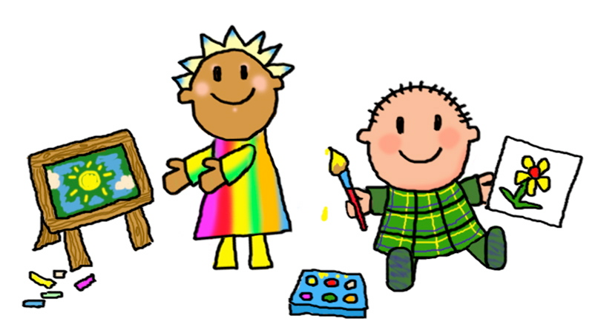  Parent signature:  Date:
Social and Emotional Learning | Maths
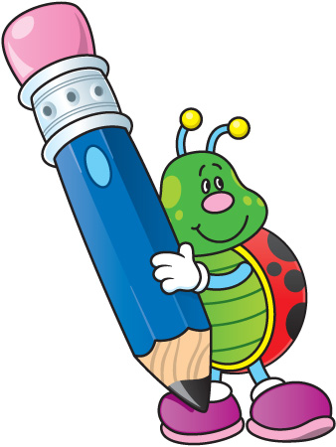  As it is almost the end of the school year we are preparing for Grade 1. Talk to you family about how you might be feeling about beginning grade 1. Draw 2 pictures of things you are looking forward to learning about or doing in grade 1.  Parent signature:  Date: | In Maths, we are learning about time. Draw 3 pictures of things that take a long time to complete and 3 things that can be done quickly.  We are also learning to tell o’clock times. Practise telling o’clock times with your family at home.  Parent signature:  Date:
- A reminder that ALL specialist classes are on Wednesdays. Students will need to wear their sports uniform on this day.
- Prep S has library on Fridays, Prep G and Prep M have library on Tuesdays.
In Reading and Writing we are continuing our learning about caring for animals, and will be learning about the structure of a procedure by identifying the different parts. In Maths, we are learning about time. In Religion, we are continuing our One Family unit where we will be exploring our own families, Jesus’ family and the Nativity story. In Inquiry, we are continuing to share stories about ourselves and create a ‘My Story’ book.

