Grade Prep Home Learning Weeks 8 & 9 Term 3 2019
Monday 2nd September- DUE: Friday 13th September

Reading | Magic Words
Please continue the reading activities that are inside your child’s reader bag for the fortnight. Reading should take between 5 and 10 minutes each day.  Please note that Readers will be sent home on Monday.  Please also take the opportunity to read through the Library books your child borrows from school. You may like to read this as a family or before bedtime.  Parent signature:  Date: | 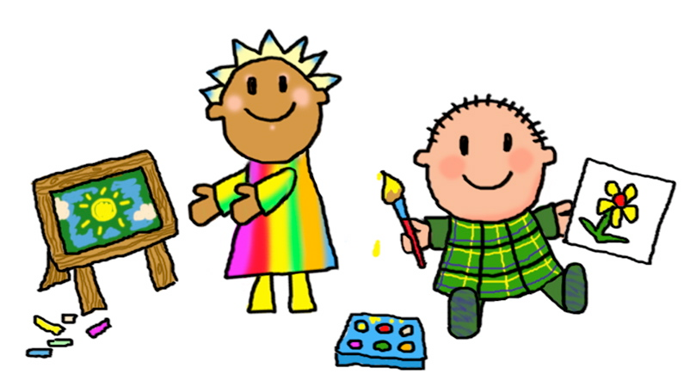  Continue to practise learning your Magic 100 Words. Remember these words ARE NOT TO BE SOUNDED OUT, they are sight words, you see them, say the words, say the letter name, say the word. Please make sure that you bring the words back each Friday and play different games to help you learn your words eg. memory, making them with magnetic letters.  Parent signature:  Date:
Maths | Inquiry
In Maths we will begin learning about length. At home, use some different materials, such as pegs, pasta, blocks etc. to measure the length of objects.  Here is an example of someone measuring the length of the toothpaste using blocks:  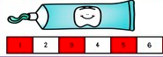  Parent signature:  Date: | During Inquiry we will begin exploring how materials can be changed, in particular, how the properties of food change by conducting some simple experiments.  At home, you might like to conduct a simple experiment with your family with bi-carb soda, vinegar and/or food colouring. Add a few teaspoons of bicarb soda into a tall cup or glass, pour some vinegar into another cup and add a few drops of food colouring. Slowly add the vinegar to the bi-carb soda and watch what changes happen!  (HINT: Please choose the surface you do this on carefully, you will want it to be clear and easy to clean!!!)  Parent signature:  Date:
- A reminder that ALL specialist classes are on Wednesdays. Students will need to wear their sports uniform on this day.
- Prep S has library on Fridays, Prep G and Prep M have library on Tuesdays.
In Reading we are developing our comprehension strategies - this means that we are exploring fiction stories, making predictions, talking about characters feeling, retelling what happened in a story and making connections. We are also continuing to explore and create our own text that describe. In Maths, we are learning about sorting shapes based on their properties and we will begin to explore length, by measuring objects using informal units such as pegs and icy-pole sticks. In Religion we are continuing our unit ‘Be like God, Be like Jesus’, where we are exploring the qualities of Jesus and ways we can act like Jesus. In Inquiry, we will begin to participate in some simple science experiments and explore how materials/food change.

