Grade One Home Learning Weeks 8 & 9 Term 3 2019
Monday 2nd September- DUE: Friday 13th September
Tasks in the shaded box are strongly recommended to be complete.

Reading | Magic Words
Read at home for 10 minutes each night - this can be achieved by reading independently, reading together with your family or having a family member read to you.  Please note, it is perfectly fine to borrow the same book for a number of days if your child is not ready to move onto another text.  Summarising the story.  When we summarise a story we retell the main events of the text.  Summarise your story after you have read it to an adult.  Did you share too much information? - choose what the most important parts are.  Did you share too little information? - think of the most important part in the beginning, middle and end.  Parent signature:  Date: | 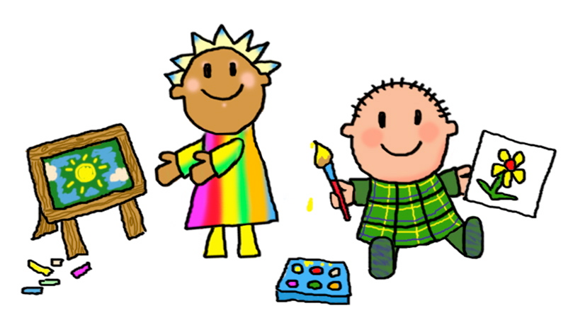  Continue to practise learning your Magic 100 Words. Remember these words ARE NOT TO BE SOUNDED OUT. Please make sure that you bring the words back each Friday and play different games to help you learn your words eg. , making them with magnetic letters, playdough, chalk etc.  Parent signature:  Date:
Maths | Inquiry
In Maths we are learning about 3D shape. Find some boxes in your home that will be going in the recycle bin. What type of 3D shape are they?  Write in your home learning book how many faces, edges and vertices it has.  Please bring in 3 small boxes to school for Maths.  Parent signature:  Date: | With an adult, think of an experiment that you would like to do at home.  Work through the following process orally or write it in your home learning book:  - Have a question you would like to find out  - Predict what will happen  - List your materials and steps  - Observe and record what happened  - Reflect on how the experiment went  Parent signature:  Date:
In Reading, we are developing our comprehension strategies - this means that we are exploring fiction stories, making predictions, talking about characters feelings, retelling what happened in a story and making connections. We are also continuing to explore and create our own texts that inform others about an animal. In Maths, we are continuing to learn about 3D shape. In Religion, we are continuing to explore stories from the New Testament. In Inquiry, we will are continuing to participate in some simple science experiments to explore how materials/food change.

