Grade 5 Home Learning Grid
The following tasks are to be completed over the next two weeks in your home learning book. Due: Friday the 13th September.
Please remember to see your classroom teacher before the due date if you would like extra support with your home learning tasks. Think about how you are going to organise your week of home learning so you are able to complete the tasks required before the due date. Shaded boxes are non-negotiables.
Reading/Diary | Writing | Maths
Read your current reading book for at least 30 minutes every night.  Record your reading in your diary every night with a family member’s signature. This is a record of reading that will be used for the Semester reports.  Remember to bring your current reading book to school every day as it will be used for your sustained silent reading.  If signed 55-60 nights- Excellent  If signed 48-54 nights- Very Good  If signed 36-47 nights- Good  If signed 25-35 nights- Satisfactory  If signed less than 25 nights- Needs Attention  Parent signature:  Date: | Star of the Week  Continue and complete your Star of the week. You will be given time in class to start your star of the week writing, but this must be finished and returned to school by Friday each week.  Remember to write why this person has been chosen and the great things you have noticed about them. Use examples to support your comments.  Week 7: Be Respectful in all spaces - Tell the Truth  Week 8: Mindfulness - Mindful Glitter Jars  Parent signature:  Date: | Have a go at the challenging problems below. Show your working out in your Maths book.  A postcard has an area of 28 square cm and a perimeter of 22 cm. What are the dimensions (side lengths) of the postcard?  A rectangular garage has an area of 27 square meters. Its perimeter is 24 meters. What are the dimensions (side lengths) of the garage?  A rectangular patio has a perimeter of 38m. Its area is 90 square meters. What are the dimensions (side lengths) of the patio?  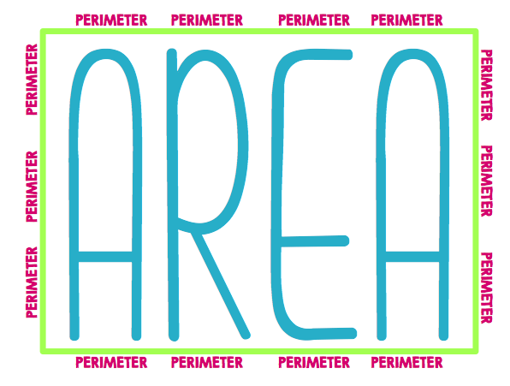  Parent signature:  Date:
Community & Events |  | CHALLENGE YOURSELF
Thank you for your tissue box donations. If you are yet to bring any to school, please bring a spare box or two!  Friday 13th September - Tabloid Sports Day on the oval and Footy Colours Day  Monday 16th September - St Lawrence has Talent Final (grades 3-6)  We are collecting any old magazines and newspapers for an activity towards the end of the term. If you have any spare and wouldn’t mind sending them in that would be appreciated. |  | Riddle  What has hands but doesn’t clap?  If a red house is made of red bricks, and a yellow house is made of yellow bricks, what is a greenhouse made of?  What has to be broken before you can use it?
Over the next fortnight, we will be focusing on: Explanation texts (Writing), Author’s Purpose (Reading), Geometric reasoning and area (Maths), Chemical Science (Inquiry), How does our experience of God change us? (RE)
5S | Sport: Wednesday | 5H | Sport: Wednesday | 5M | Sport: Thursday

